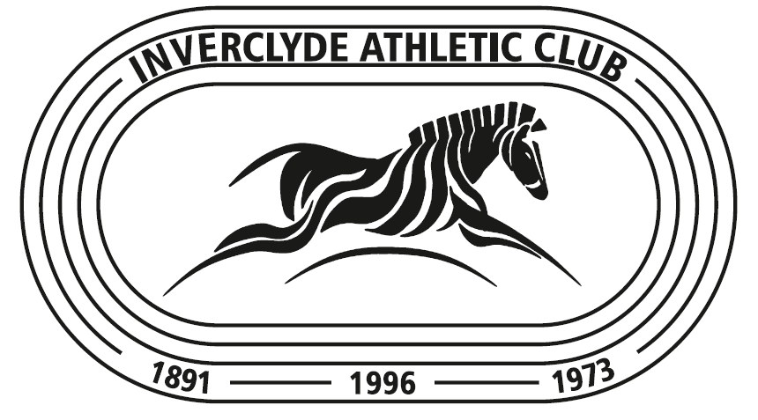

Inverclyde Athletic Club

Membership Application Form

Senior Members

Additional Information

Inverclyde A.C. is an inclusive club and aims to create the best possible opportunities for its members. As well as encouraging and supporting members to develop their talents and athletic interests, the club also depends on its members to support the club, and help in a variety of areas. Please complete and return this Form as set out below / over together with your IAC Membership Form

Name______________________________________________________

Interests (Please tick all appropriate areas) Cross Country ☐ Track ☐ Field ☐

Road ☐ Fell/Mountain ☐

Officiating
Do you have an Athletics Officials Qualification? ☐

If not, would you like to attend an Officials Course ? ☐
If you have, would you be willing to assist the club with any Officials duties? ☐
If you have ticked any of the above; you will be contacted by Gerry Gaffney

Coaching
Do you have an Athletics Coaching Qualification? ☐
If not, would you like to attend a coaching course? ☐
If you have, are you willing to assist in the club’s coaching programme? ☐
If you have ticked any of the above; you will be contacted by Janice Hendrie

Volunteering
Have you any Volunteering experience in a (sports) club environment? ☐
If not, would you like to gain some experience and become a Club Volunteer? ☐
If you have ticked any of the above; you will be contacted by Gerry Gaffney

IT Skills
Are you interested in assisting with:

Website ☐ Promotional Activities ☐ Results ☐ Committee ☐

Other?_____________________________

Maintenance
Do you have any skills which would be helpful in maintaining either clubhouse or club equipment? ☐

Area of skill______________________________________________

Returning completed form.

- By post: IAC Membership Secretary, 197 Old Inverkip Road, Greenock. PA16 9EW

- By e-mail: gerard.gaffney@ntlworld.com

Please note that if you are sending the form by e-mail, you must send it encrypted with the password sent by a separate e-mail.

- By hand: pass it to a club Committee member or a Coach

Thank You
IAC Committee
May 2018

Registered Charity SC 047791

